Carbon Footprint Calculator (Java + JavaFX)
Shashank Singh 24BCE10827

1. Introduction
Climate change is one of the most critical challenges of the modern world. Individual activities related to electricity usage, transportation, and dietary habits contribute significantly to carbon emissions. However, people often lack awareness about how their daily actions impact the environment. Without proper tools to track and analyze emissions, it becomes difficult to make informed decisions about reducing one’s footprint.
The Carbon Footprint Calculator is a Java-based desktop application that addresses this problem by allowing users to record daily activities, automatically calculate resulting emissions, visualize monthly patterns, and receive personalized recommendations. The application is designed to be simple, lightweight, and educational, helping users take actionable steps toward sustainable living.

2. Problem Statement
Most individuals do not have visibility into their day-to-day carbon emissions. This lack of understanding leads to inefficient energy consumption, increased transportation emissions, and unsustainable food choices. There is a need for an accessible, user-friendly system that quantifies emissions and provides analytical insights in order to drive awareness and behavioral change.

3. Objectives
The primary goals of the project are:
- Provide a desktop application for logging carbon-related activities.
- Automate the calculation of carbon emissions using standardized factors.
- Present monthly totals and category-wise breakdowns for better understanding.
- Compare user emissions against national average benchmarks.
- Support CSV data import for bulk data entry.
- Provide actionable recommendations for reducing emissions.
- Persist user data securely using SQLite.
- Keep emission factors configurable for flexibility.

4. Scope of the Project
In-Scope Features
- Manual activity entry
- CSV import functionality
- Emission calculation
- Dashboard visualization with charts
- Monthly aggregation
- National average comparison
- Recommendation generation
- Local SQLite database storage
Out-of-Scope Features
- Multi-user login
- Cloud synchronization
- Real-time API integration
- Mobile application
- Hyper-accurate geographic emission factors

5. Tools and Technologies Used
- Programming Language: Java 17
- User Interface Framework: JavaFX
- Build Tool: Maven
- Database: SQLite (JDBC)
- JSON Processing: Jackson Databind
- IDE: VS Code / IntelliJ IDEA
- Visualization: JavaFX PieChart
These technologies were chosen for their portability, performance, and suitability for GUI-driven applications.

6. System Architecture
The application uses a modular architecture for cleaner separation of responsibilities.
Modules Overview
- User Interface Layer (JavaFX)
  - Activity entry forms
  - Buttons for saving and importing
  - Dashboard visualizations
  - Recommendation display
- Business Logic Layer
  - EmissionCalculator performs emission calculations
  - RecommendationEngine analyzes monthly data
- Data Persistence Layer (SQLite)
  - ActivityDAO handles database queries
  - DatabaseManager manages connections
- Data Ingestion Layer
  - CSVImporter processes CSV files
  - FactorLoader reads JSON emission factors
Data Flow
User Input / CSV → ActivityEntry → SQLite Database →
EmissionCalculator → Dashboard Charts → Recommendations
This flow ensures data consistency and easy retrieval.

7. Methodology
The project followed a structured development approach.
7.1 Requirement Analysis
Identified the need for:
- Tracking energy, transport, and food-related activities
- Emission factor-based calculations
- Monthly summaries and comparison metrics
7.2 Design Phase
Designed:
- Database schema
- UI layout using JavaFX components
- Modular packages for calculator, ingestion, persistence
7.3 Top-Down Modularization
Broke the system into:
- UI components
- Calculation module
- Persistence module
- Import module
- Recommendation module
7.4 Algorithm Development
Emission Calculation:
CO₂ Emissions = Activity Value × Emission Factor
Monthly Aggregation:
For each activity in current month:
Add to category total
Recommendation Logic:
- Identify highest-emitting category
- Compare with national average
- Provide targeted suggestions
7.5 Implementation
Implemented UI, CSV importer, emission calculator, and dashboard with exception handling.
7.6 Testing
Tested manually and through various CSV scenarios.

8. Implementation Details
8.1 User Interface
Built using JavaFX with:
- DatePicker
- ComboBox
- TextField
- PieChart
- Buttons
- ListView
Layouts use VBox and HBox for clean separation.
8.2 Database
- SQLite database carboncalc.db created automatically
- Table: activities
- Stores date, category, subtype, value, unit, and notes
8.3 CSV Import
The system:
- Normalizes date formats
- Skips invalid rows
- Handles empty fields
- Validates numeric values
- Inserts valid rows into database
8.4 Emission Calculation
Factors loaded from JSON file:
config/emission_factors.json
Categories include:
- Energy
- Transport
- Food
Each subtype has a numeric multiplier.
8.5 Dashboard
Displays:
- Monthly total emissions
- Category breakdown
- Pie chart visualization
- Comparison with national average
8.6 Recommendation Engine
Generates suggestions such as:
- Reduce meat meals
- Use public transport
- Lower electricity consumption

9. Testing and Analysis
Test scenarios performed:
Manual Entry Test
- New records saved to database
- Dashboard updated instantly
CSV Import Test
- Clean CSV imported correctly
- Malformed rows handled gracefully
Emission Accuracy Test
- Verified calculations using reference factors
Database Test
- Data persisted between sessions
Recommendation Test
- Suggestions matched emission patterns
Overall, the application performed reliably with correct calculations.

10. Results
- Successfully tracks daily activities
- Provides accurate monthly emission totals
- Shows category-level insights
- Compares user data with national averages
- Offers meaningful recommendations
- Efficient CSV import supported
- Stable local database storage
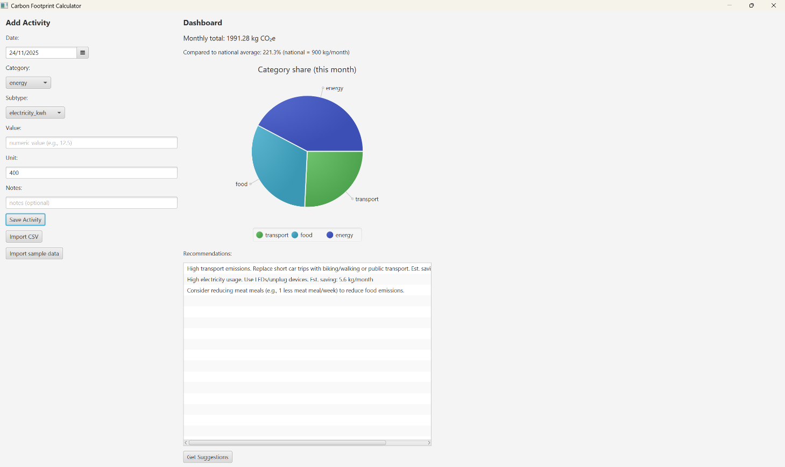

11. Conclusion
The Carbon Footprint Calculator is an effective tool for personal sustainability tracking. It provides users with meaningful insights into their carbon footprint using a simple and interactive interface.
The project demonstrates strong modular design, practical use of JavaFX, and efficient data handling through SQLite and JSON.
This system fulfils its objectives and can serve as a foundation for larger sustainability-related applications.

12. Future Enhancements
- Yearly and weekly charts
- PDF report generation
- User profile system
- Cloud synchronization
- Mobile app version
- More activity categories (waste, water, flights)

13. References
- Official JavaFX Documentation
- SQLite JDBC Documentation
- IPCC Emission Factors
- Government Carbon Emission Reports

